Architecture Document

# Key:

Person: Persons are the actors in the system.

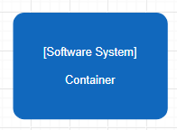

Software System: A software system is the highest level of abstraction, which includes the software we are modelling.

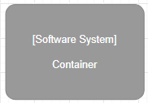

Software System (Grey): The grey notation refers to a software system that already exists.

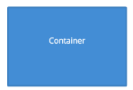

Container: A container refers to an application or data store.

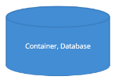

Container (Database): This notation refers to a container that is specifically a database.

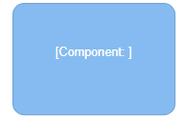

Component: A component refers to a class or many classes within a container that execute in the same process space.



Arrows: Arrows represent relationships between all of the above

# C1

In the system context diagram you can see the 3 actors, the Visitor, the Secretary and the Employee. In this diagram it is shown that only the secretary directly interacts with the application.

# 

# 

# C2

C2, also known as the container diagram goes a level deeper into the Secretary Application mentioned in C1. It shows the specific technologies that are used in the application.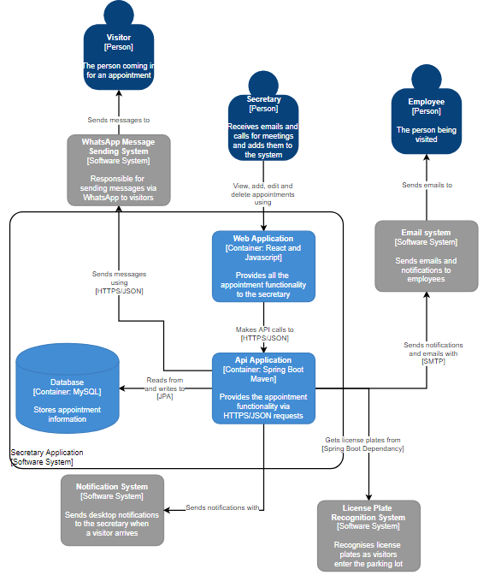

# C3

C3, the container diagram shows what makes up a single container. In this case the components that make up the Api Application container are shown in greater detail. Because many of the systems such as Mail, WhatsApp and Notifications have not been finished yet they have no components.

# 

# C4

Because the code is still fluctuating day to day a code diagram would not be appropriate at this time and has therefore been left out of this document.